PROJECT ON HEART DISEASE
CREATED BY – SHRADDHA SHARMA
REGISTRATION NUMBER- 25MIM10134
TOPIC- HEART DISEASE

OVERVIEW
A machine learning based analysis of heart disease risk using a clinical dataset. The project focuses on identifying key factors influencing diagnosis and predicting patient risk levels. This project analyzes heart disease data and predicts the likelihood of a patient developing heart related conditions using machine learning techniques. A comprehensive heart disease prediction model built using supervised learning methods, focused on uncovering patterns in patient health data.
FEATURES
- Data upload and input support
- Automated data and pre processing
- Machine learning based risk prediction
- Model performance evaluation
- Feature importance insights
- User friendly output visualization
- Scalable architecture
TECHNOLOGIES AND TOOLS USED
- Programming language:
Python 3.x – core language for model development and data handling.
- Libraries and frameworks
- Pandas – data loading, cleaning, manipulation
- Scikit learn – machine learning models, preprocessing pipelines, evaluation
- NumPy – numerical computations and array operations
- Matplotlib – performance and feature importance visualization
- Development environment
Google colab – code execution and interactive model development.
- Version control and deployment
Git and GitHub – source code management, documentation, and submission
- Dataset source
Kaggle datasets – heart disease dataset (csv) used for training and testing the model.
STEPS TO INSTALL AND RUN THE PROJECT.
Step 1 – downloading the heart disease dataset from Kaggle datasets and uploading it to drive.
Step 2 – mounting the drive in google colab.
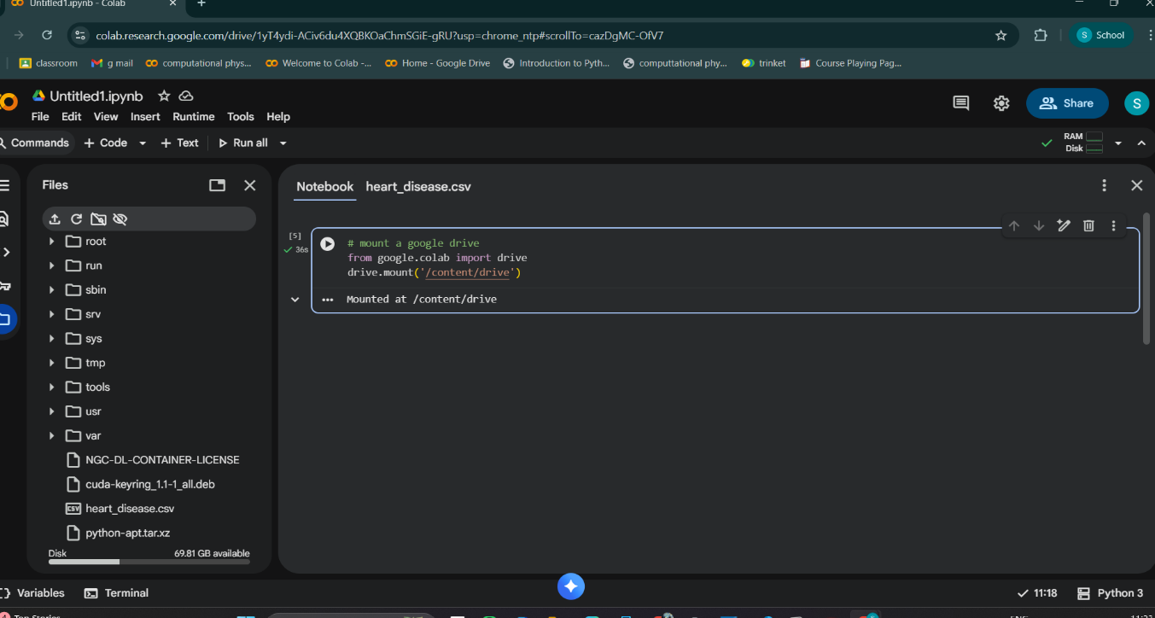

Step 3 – importing pandas library
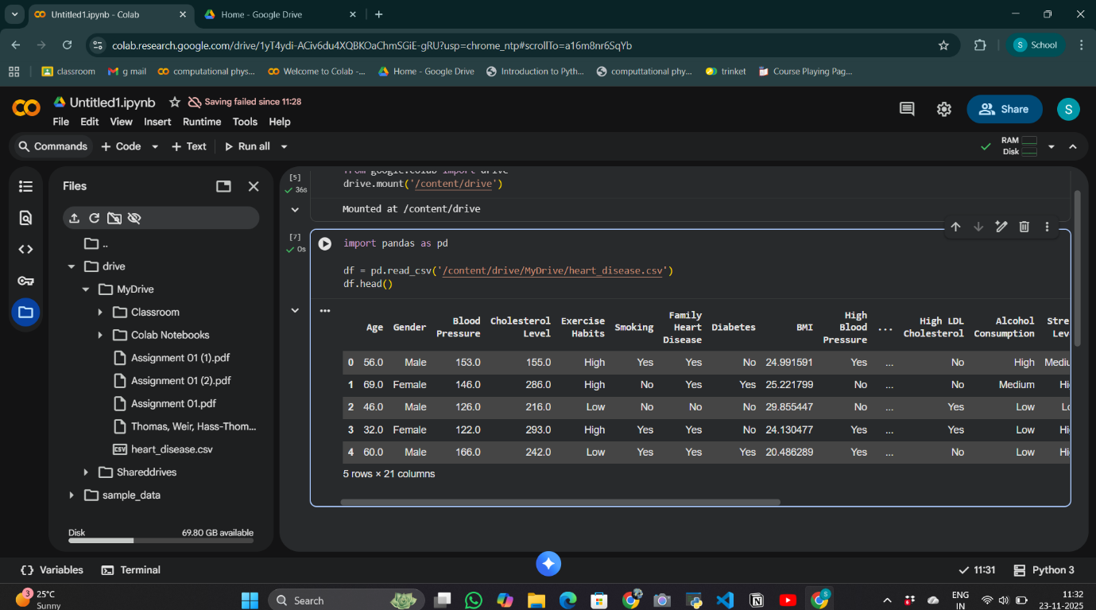

Step 4 – preprocessing data or understanding data
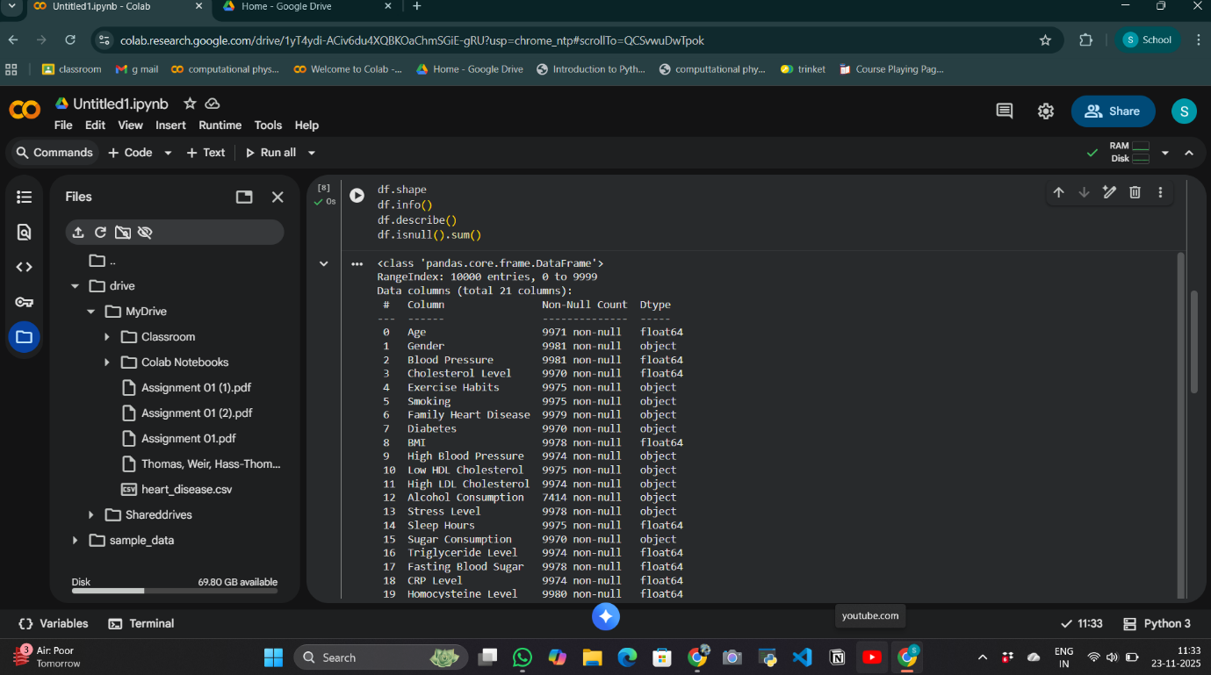

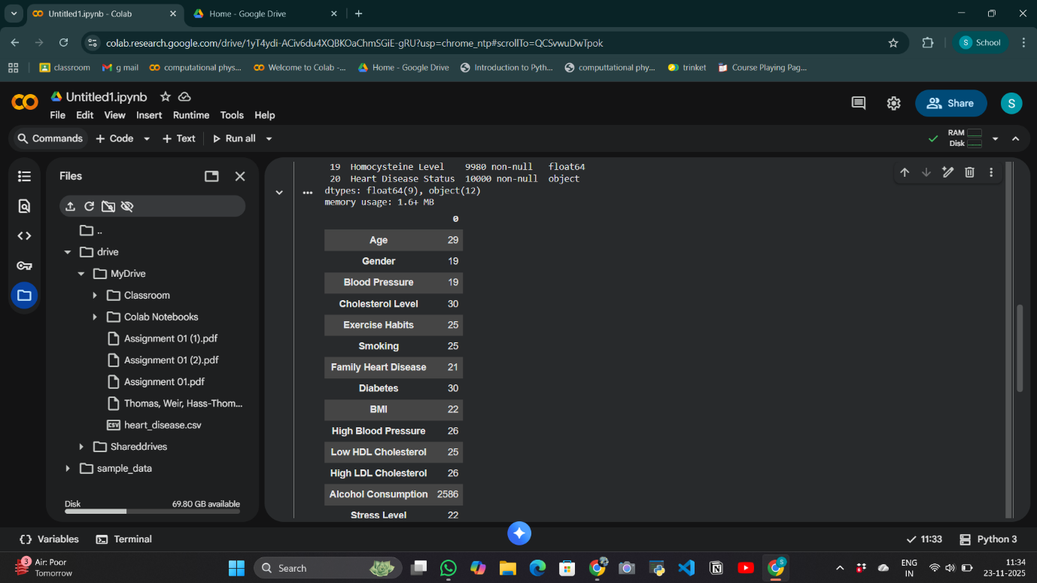
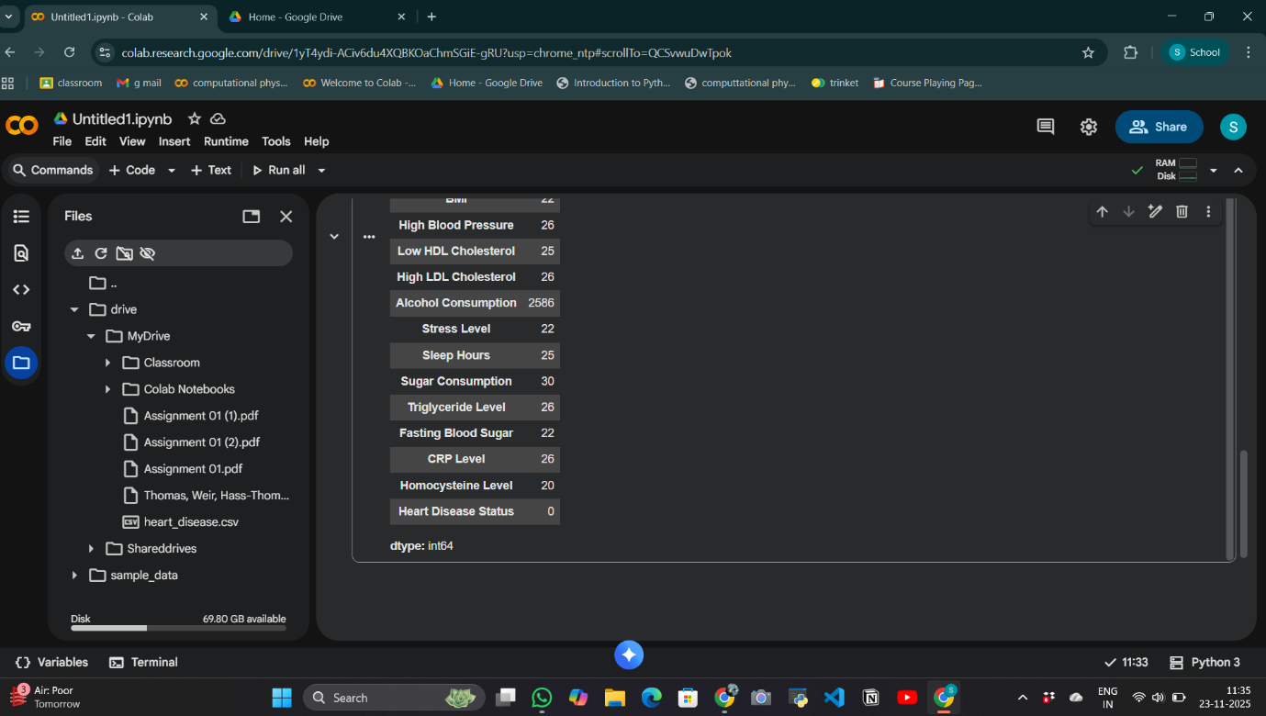

Step 5 – inspecting and standardizing feature names to ensure consistency during preprocessing.
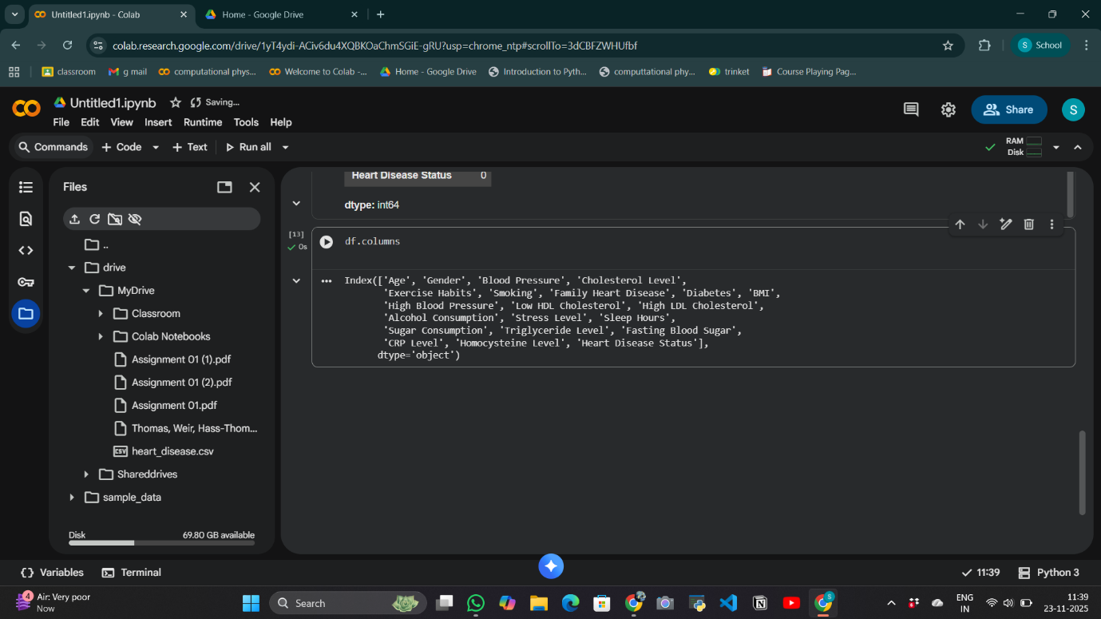

Step 6- ensuring proper preprocessing and mapping of features during mode training
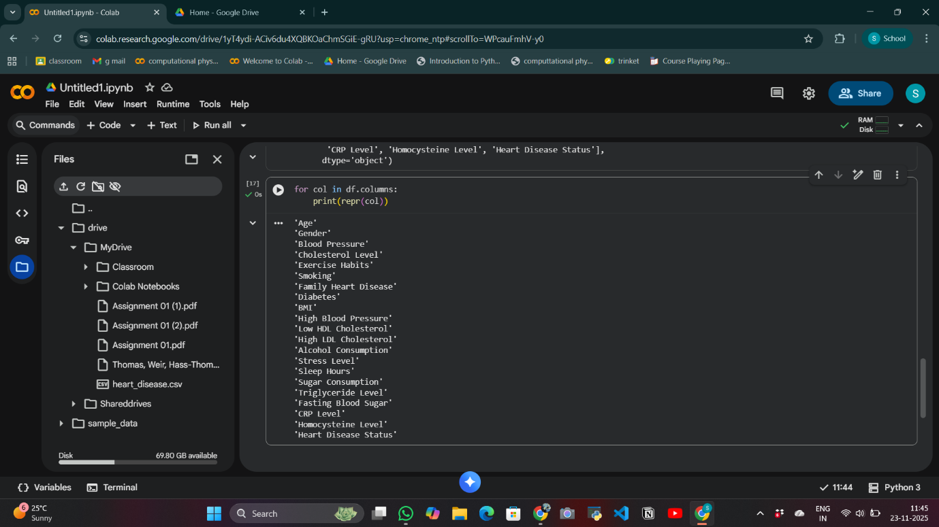
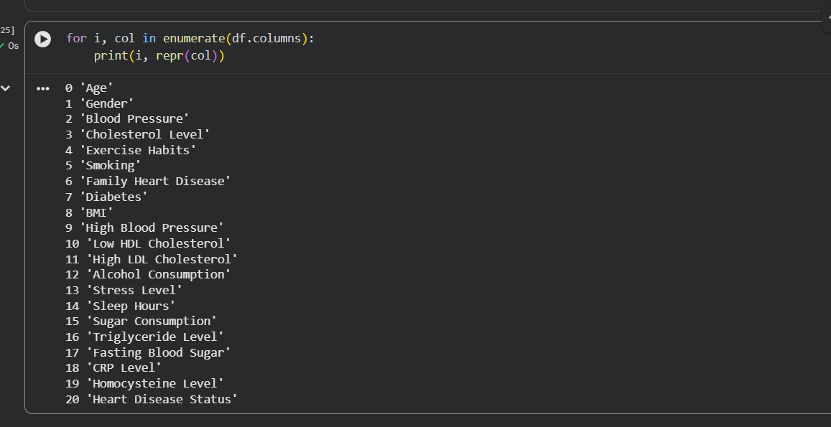
Step 7 – generating a correlation matrix heatmap to analyse relationships between numerical features.
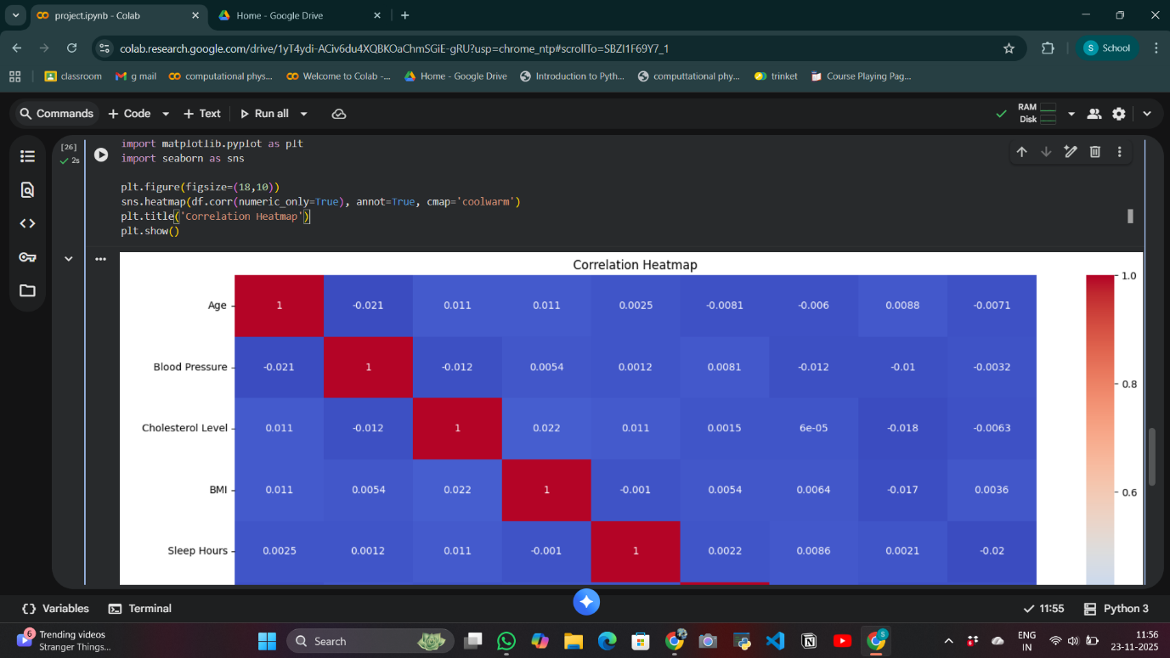
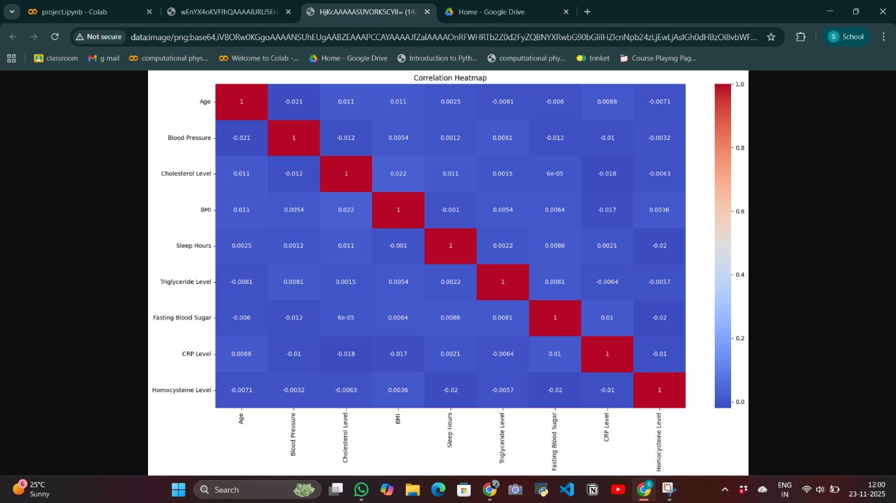

Step 8 – visualizing the distribution of the ‘heart_disease_status’ variable in the dataset.
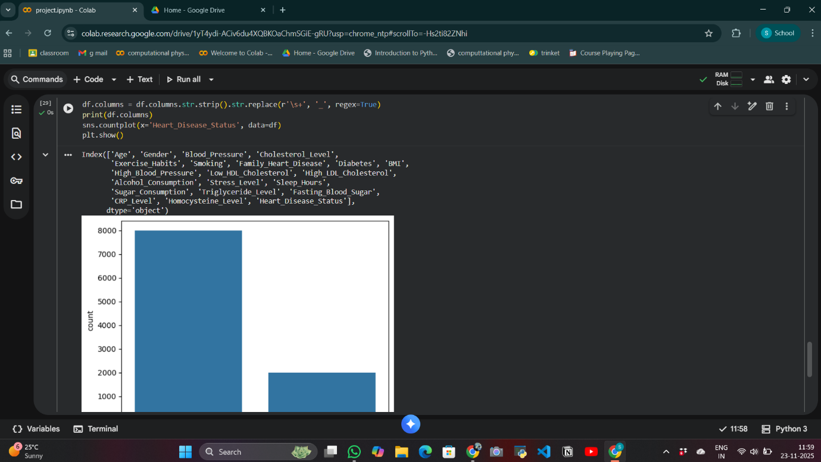
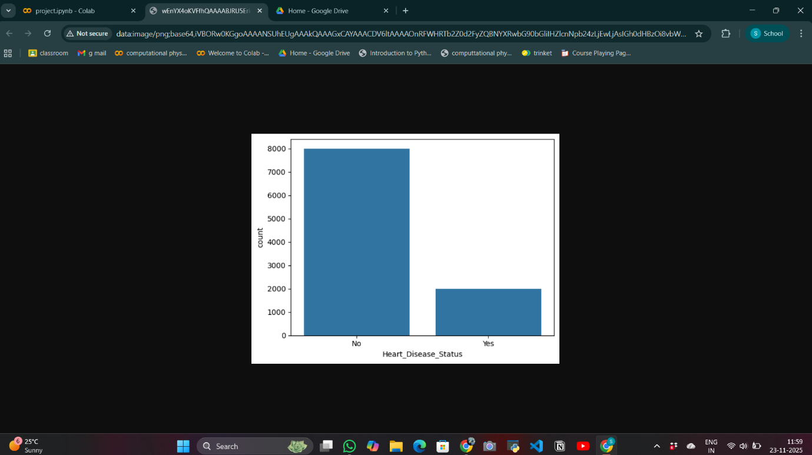
Step 9 – identifying categorical columns
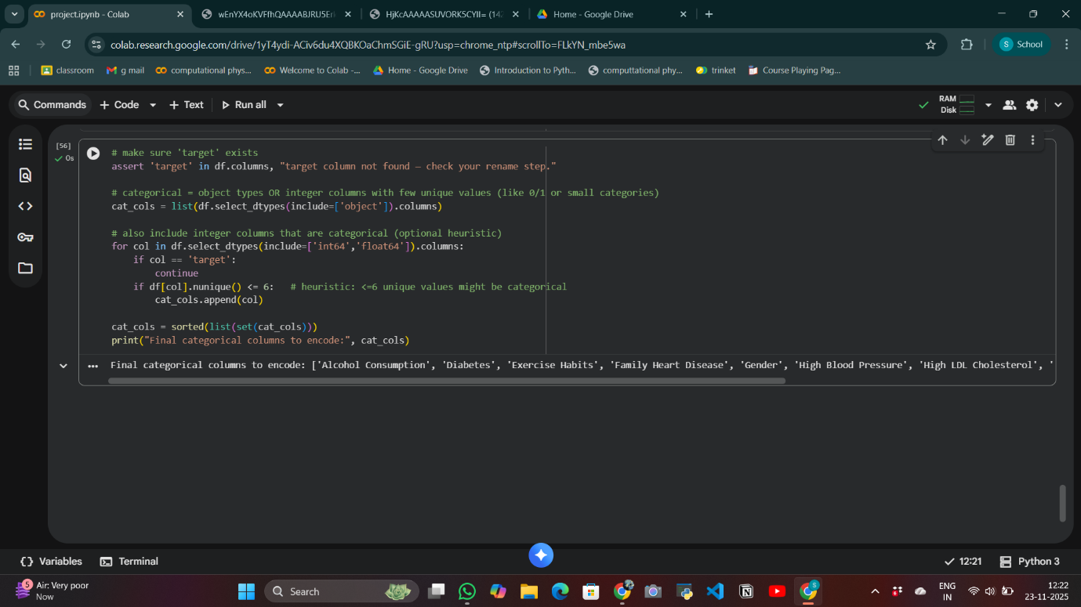
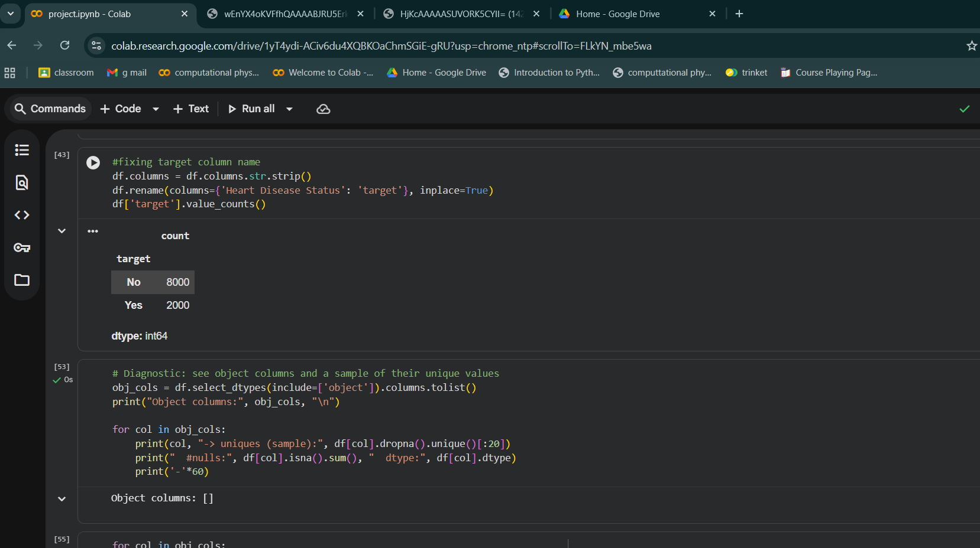
Step 10 – testing the model
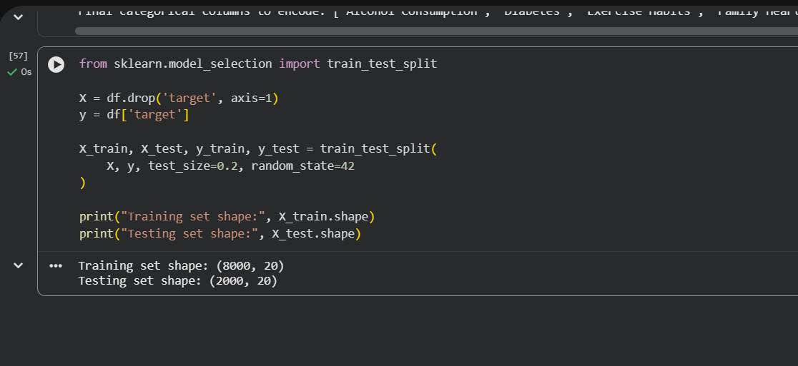
Step 11 – training the machine learning model
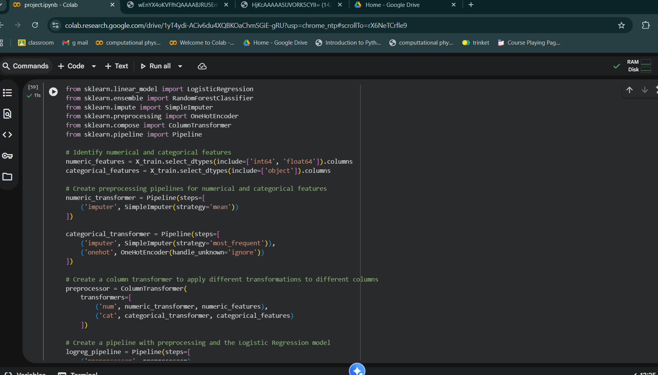
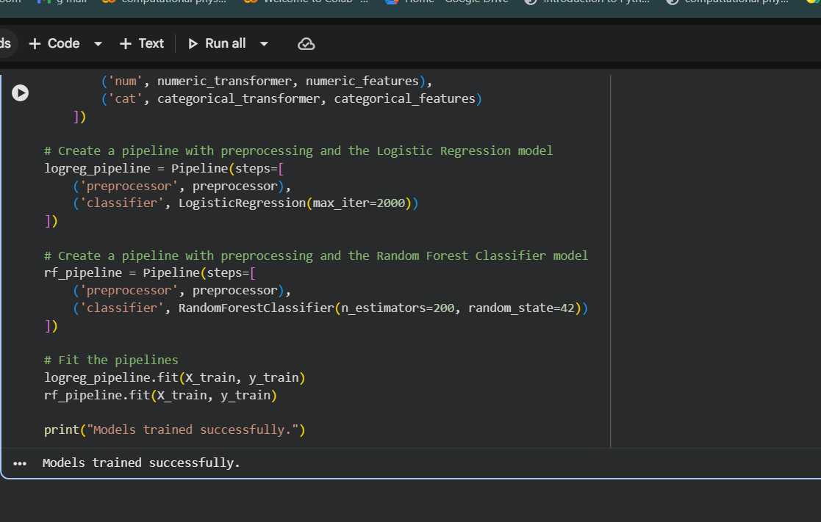
Step 12 – evaluating the model
